**Service Oriented Architecture – Documentation**

The following application is a simple way to find any sort of Entities inside a database. As an example, it used pets and animals as base entity and it was expanded also for different kind of items, from small to big ones. The application uses on the server side Express JS deployed on using Firebase and Firebase Storage as database for it. The client is a web application in React.

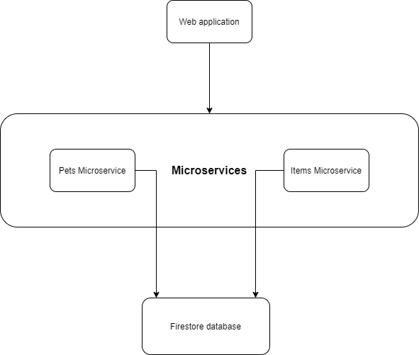

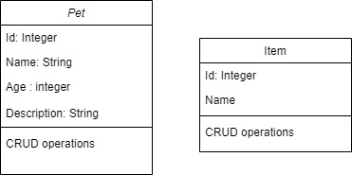

The SOA patterns used are composed of:

**Service Provider -** the actual server implemented in JavaScript

**Service Broker –** The Firebase container

**Service consumer –** The React web application